Paper accepted by the IRRODL Special Issue "AI e-Learning and Online Curriculum"

The Effects of Applying Experiential Learning into the Conversational AI Learning Platform on Secondary School Students

Ting-Chia Hsu¹, Hal Abelson², Jessica Van Brummelen^{2*}
¹Department of Technology Application and Human Resource Development, National Taiwan Normal University
²Department of Electrical Engineering and Computer Science, Massachusetts Institute of Technology, USA
E-mail: jess@csail.mit.edu

Abstract
The purpose of this study was to design a curriculum of artificial intelligence (AI) application for secondary schools. The learning objective of the curriculum was to allow the students to learn the application of conversational AI on a block-based programming platform. Moreover, the empirical study actually implemented the curriculum in the formal learning of a secondary school for a period of 6 weeks. The study evaluated the learning performance of the students who were taught with the cycle of experiential learning in one class, while also evaluating the learning performance of the students who were taught with the conventional instruction, which was called the “cycle of doing projects” in the current study. Two factors, learning approaches and gender, were taken into account. The results showed that the learning effectiveness of females was significantly better than that of males regardless of whether they used the learning approaches of experiential learning or conventionally doing projects. Most of the males tended to be distracted from the conversational AI curriculum because they misbehaved during the conversational AI process. In particular, in the performance of using the Voice User Interface of the students learning with the conventional learning approach, the females outperformed the males significantly. The results of two-way ANCOVA revealed a significant interaction between gender and learning approaches on the computational thinking concepts. The females with the conventional learning approach of doing projects had the best computational thinking concepts in comparison with the other groups.
Keywords: gender studies, conversational AI application, experiential learning, block-based programming

Introduction
In the technology era, from understanding complex terminology, syntax, and error messages, to learning about functions, iterations, and new algorithms, some students even at the university level have difficulty learning to program (Piwek & Savage, 2020). Because of this, many researchers have investigated innovative and useful approaches to teach and learn computer programming. For example, researchers have proposed an experiential learning cycle from project-based learning for learning computer science (Pucher & Lehner, 2011). These methods involve concrete experience, the application of acquired knowledge, and the contextualization of projects in the real world and hands-on implementation, which are highly relevant to developing computer programs (Efstratia, 2014; Sendall, et al., 2019).
With the fast-paced, continual development of computer science, including huge gains in artificial intelligence (AI) and machine learning, the application of AI has become popular in our daily lives due to the high-speed development of hardware (Hsu, et al., 2021). One rapidly-growing subfield includes conversational AI, which is the ability of machines to converse with humans, including voice-based technologies such as Amazon’s Alexa. The goal of the current study was therefore to investigate the effectiveness of using the cycle of experiential learning and the cycle of doing projects in a conversational AI curriculum. Specifically, this research investigated the two different teaching approaches, the cycle of experiential learning and the cycle of conventional doing projects, with a visual programming interface for conversational AI applications using the MIT App Inventor (Van Brummelen, 2019). The conversational AI curriculum we developed allows young students to connect the application of audio interaction with the Internet of Things (IoT) or the simulative interaction in the block-based programming environment. This innovative, applied AI curriculum can be implemented in junior high schools.
For novices and young students, there is evidence that visual programming, which is also termed as block-based programming, is more effective in teaching programming than conventional command-line programming with complex syntax (Cetin, 2016). In this study, “visual programming tools” refer to block-based programming tools such as MIT App Inventor or Scratch. In comparison with conventional text-based programming, the visual programming tools such as MIT App Inventor are helpful for novices to fully focus on learning to solve problems and understand the logic and framework of the overall program, rather than needing to focus on specific semantics or syntax (Grover, et al., 2015; Hsu, et al., 2018; Lye & Koh, 2014).
In conventional programming, programs are be written with strict syntax, which can be difficult for general populations to learn, especially for non-native English speakers, since the program cannot run successfully when the program has even minor spelling errors. On the other hand, if students utilize block-based programming to build the program, these errors will not occur. Block-based programming emphasizes recognition over recall through having code-blocks readily available in the visual interface. Furthermore, the blocks are categorized according to their function or logic. Students only need to concentrate on using appropriate blocks to complete the work they want to do or the effect they want to have, rather than memorizing syntax or particular keywords of the programming language. Moreover, the shape and color of the blocks provide the students with scaffolding to emphasize which blocks can be linked together and how code can (or cannot) be developed. During this process of visual code development, students can learn the concepts of composing programs and that different blocks have various functions or properties. With block-based programming, students usually need only to drag and connect the blocks, reducing the cognitive load on the students and allowing them to focus on the logic and structures involved in programming rather than the syntax of writing programs (Kelleher & Pausch, 2005). Block-based programming provides students with media-rich learning environments, allowing them to connect with various personal interests (Brennan & Resnick, 2012). A recent study revealed that learners were very positive about the creation of applications (apps) by visual programming and project development; thus, the scholar recommended that novice programmers create apps with block-based programming (Chiu, 2020). Finally, when students use a visual programming tool to write a program, they tend to focus on problem solving. Researchers have indicated that visual programming tools have a positive impact on programming self-efficacy and decrease student frustration (Yukselturk & Altiok, 2017).
It is especially important to reduce learning frustration for those who are underrepresented in the computer science field, as they face additional challenges when first entering the field. Furthermore, it is important to increase their participation in computer science, as underrepresented groups provide unique perspectives and diverse, innovative solutions. In this paper, we investigate the effectiveness of learning techniques by gender, since historically, females have been underrepresented in computer science, and the relative number of females entering the field has significantly decreased over the past 30 years (Weston, Dubow, & Kaminsky, 2019). By determining and utilizing the most effective pedagogical techniques for computer science by gender, more females may enter the field, and the gender gap may close.
A previous study has shown that gender impacts the ease of use and intention to use block-based programming (Cheng, 2019). Nonetheless, very little is known about the effect of gender on learning computational thinking skills in primary and secondary education (Kalelioğlu, 2015). Due to the shortage of females participating in science, technology, engineering and mathematics (i.e., STEM) domains in comparison with the number of males, many countries have recently encouraged females to participate in those domains. However, researchers have indicated that the participation rate of females is still lower than that of males in the computer science domain (Cheryan, et al., 2017). The difference in male and female interest in computer science likely originates from how females generally have less experience learning computer science during childhood (Adya & Kaiser, 2005; Schulte & Knobelsdorf, 2007).
Information processing theory research has also indicated that different genders have different perceptions and processing modes in the brain (Meyers-Levy, 1986). Males tend to rely on the right brain to process and select the input information from outside. Thus, they often pay attention to visual information or contextual signals, while ignoring the details of processing methods (Meyers-Levy, 1989). Conversely, females tend to prefer using their left brain to accept and analyze the input information in detail, often resulting in higher stress levels. Moreover, females tend to relate, collaborate and share information with others (Putrevu, 2001). Different genders have different information processing procedures in the brain. Meanwhile, different genders tend to filter and accept different types of input from the same information (Martin, et al., 2002). Accordingly, it is worth further exploring the effect of gender on new curricula such as the conversational AI curriculum with MIT App Inventor.
A previous study showed there was no significant difference between genders in students’ performance when programming using code.org, although females’ average reflective ability was slightly higher than that of males (Kalelioğlu, 2015). Another study also showed that there was no significant difference between genders in LEGO construction and related programming, but females paid attention to the instructions of the task, whereas males rarely did (Lindh & Holgersson, 2007). On the contrary, some studies indicate significant gender differences in learning to program and acquiring computational thinking skills (Korkmaz & Altun, 2013; Özyurt & Özyurt, 2015).
According to the cognitivist view of information processing theory, females tend to perceive information in detail and concentrate on sharing and correlating information when their brain processes the information, while males tend to pay attention to the information context (Putrevu, 2001). According to the selective input of information and the perspectives of gender schema in information processing theory, males and females have slight differences in their methods of selecting and processing information.
Many countries have encouraged females to engage in Science, Technology, Engineering and Mathematics (STEM). Females’ experiences during K-12 education affect their choices to continue with those subjects in the future. In addition, K-12 AI education is quickly becoming popular (Long & Magerko, 2020; Touretzky et al., 2019). Due to this popularization and gender gap in STEM, it is important to explore the effects of gender on AI education. Specifically, we aim to explore these effects using the conversational AI curriculum developed by Van Brummelen (2019). AI literacy is important, and one aspect of AI that is incredibly prevalent with Alexa, Google Home, Siri and so on is voice-based AI technology. Voice technology is great for people who do not have the ability to use conventional input devices. They can directly talk to the computer or smartphone instead of typing or using a mouse. Figure 1 shows an example of the application of conversational AI.
Figure 1.
An Example of a Conversational VoiceBot in the Alexa Simulator

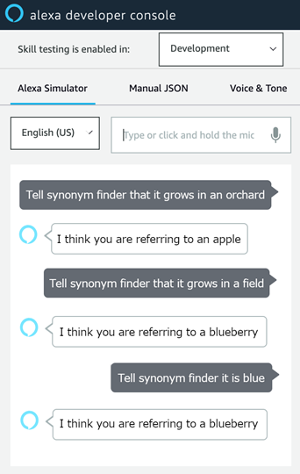
The conversational AI system providing the Voice User Interface (VUI) is sometimes also called a VoiceBot, and is an intelligent assistant for humans’ daily life, which interacts with people through voice conversations. Conversational AI is the skeuomorphism of VUI. The innovation of this study was to implement the conversational AI curriculum in the formal classroom setting of a secondary school. The two approaches used to instruct this conversational AI curriculum in the current study involved the cycle of doing projects and the cycle of experiential learning. It was expected that the junior high school students would gain hands-on experience of programming and the application of AI in the conversational AI curriculum.
The curriculum teaches students to develop mobile applications and Amazon Alexa skills, which are programs that run on voice-first Alexa devices, using MIT App Inventor (Van Brummelen, 2019). MIT App Inventor is a block-based programming tool that encourages the practice of computational thinking, including logical and problem-solving processes. Accordingly, the experimental group employed the cycle of experiential learning in the conversational AI curriculum. Whether different learning approaches (i.e., the conventional instruction using the cycle of doing projects vs. the cycle of experiential learning) and different genders would have effects on the learning effectiveness of the conversational AI, the performance of VUI, and the computational thinking concept scale of the young students was evaluated. The research questions were addressed as follows.
(1) Does gender (i.e., males and females) and learning approach (i.e., cycle of doing projects and cycle of experiential learning) affect the learning effectiveness of the conversational AI curriculum?
(2) Does gender and learning approach affect VUI performance in the conversational AI curriculum?
(3) Does gender and learning approach affect student understanding of computational thinking concepts?

Method
Different Learning Approaches Used for Conversational AI Instruction
The conversational AI used in this study involved using audio to control Alexa. To make an Alexa skill, the student has to learn to write the conversation program with block-based programming. First, the student logs onto MIT App Inventor, and initializes the Alexa skill dragging from the block menu, shown as step 1 in Figure 2. Secondly, the student drags-and-drops blocks to program the Alexa Skill, shown as step 2 to step 4 in Figure 2. Thirdly, the student clicks a button to send the skill to Amazon. Finally, this converts the blocks into text-based code, which is readable by Alexa devices or the Amazon website shown in the right screenshot in Figure 2.
Figure 2
An Example Program in the Block-based Programming Conversational AI Interface

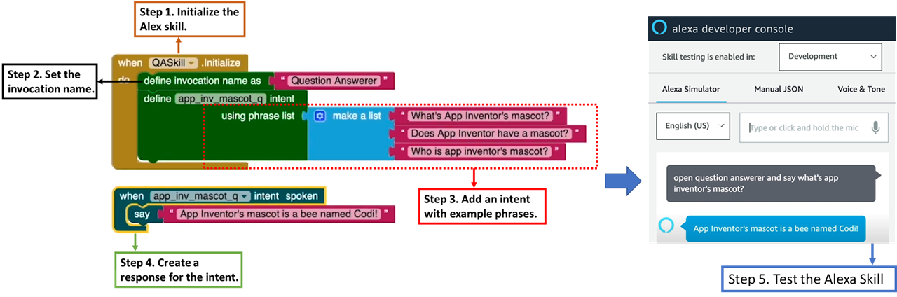

This conversational AI tool in the block-based programming environment was developed for K-12 students to create their own conversational agents (Van Brummelen, 2019). Accordingly, the user can chat with Alexa or the Alexa simulator website after the students write the conversational AI program. The Amazon Company has also embedded natural language processing inside their Alexa system and simulator. The combination of Alexa in Amazon and MIT App Inventor will become a friendly learning tool and resource for the primary or secondary school students to experience and apply conversational AI, although they are not undergraduates in the department of computer sciences. The system framework behind the block-based programming platform is revealed in the following Figure 3. The system ensures low barriers to entry for primary and secondary school students. Otherwise, creating Alexa skills can be difficult, even for a student majoring in computer science. Without the interface, connecting a lambda function on AWS to the voice user interface can be complicated. However, the block-based interface design in Figure 3 abstracts all of that, simplifying development of students’ own conversational agent.
Figure 3
System Framework of the Conversational AI Programming Tool in MIT App Inventor (Van Brummelen, 2019)

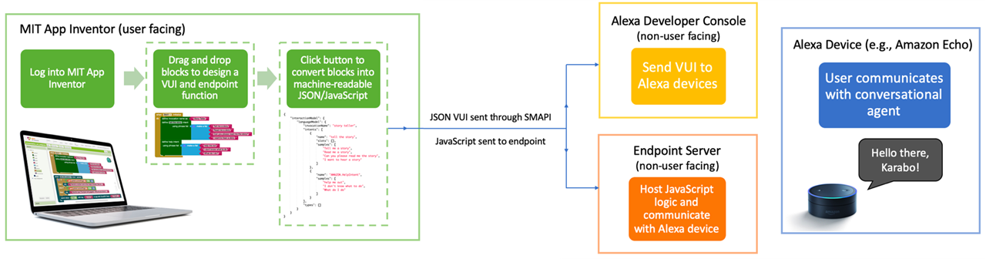

Conversational AI directly relates to Brennan and Resnik’s computational thinking skill framework (2013). In the curriculum, students engaged with CT concepts including events, conditionals, data, sequences, loops, parallelism, operators; CT practices such as being incremental and iterative, testing and debugging, reusing and remixing, abstracting and modularizing; and CT perspectives like expressing, connecting, questioning and so on. In addition to computational thinking being naturally embedded in the conversational AI curriculum, the AI-specific concepts, practices and perspectives are also learned from the curriculum, including classification (e.g., determine intent), prediction (e.g., predict best next letter), generation (e.g., generate text block), training, testing, validating (e.g., vary training length), project evaluation (e.g., question project ethics), and so on.
It is hypothesized that an appropriate instructional approach will be helpful for assisting the students in learning to make conversational AI in computer education. Therefore, this empirical study aimed to evaluate two different learning approaches in two classes respectively. One class adopted the cycle of experiential learning; its instructional design is exhibited in Figure 4. The students had concrete experience of using conversational AI first. For example, they used “Hey Google” to give their mobile phone commands with oral input rather than textual input, and found the oral and data response of the smartphone. The students had to fill out a worksheet about what they observed and found after they experienced the usage of conversational AI in their daily life. At this stage, they also had to think about new tasks. Therefore, the teachers let the students have conversation with the computer, and the students filled out the blanks on the worksheet to show what they said and how the system reacted. The students also practiced problem decomposition in this stage. After the students progressed to the abstract conceptualization stage, they had to practice pattern recognition and abstraction for problem solving. The students used their Amazon account to log into MIT App Inventor, but they did not write their own program yet. The teachers provided them with different blocks, and asked them to conceptualize which block could be used for which task. Finally, in the active experiment stage, the students actually implemented their own program and tested the running results of the program. If they encountered any problems, they had to debug and revise the program. During the process, they could ask the teachers questions if they had a problem.

Figure 4
Experiential Learning Cycle was Integrated into the Learning Process of the Experimental Group

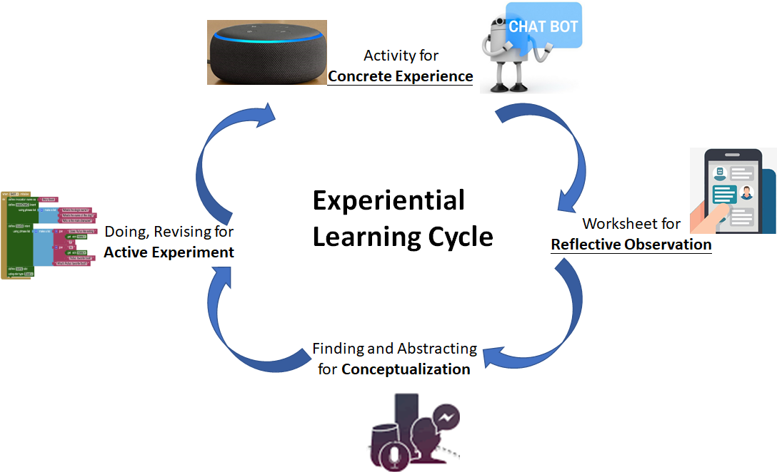

The conventional instruction approach was used in the other class. The conventional instructional approach here refers to the cycle of doing projects shown on the left of Figure 5. The teacher guided the students step by step through the process. Therefore, the students followed the directions of the teacher and imitated the demonstration of the codes shown by the teacher when the students implemented the project of conversational AI. The difference between the cycle of doing projects in the conventional instruction of this study and the cycle of experiential learning is compared and illustrated in Figure 5.

Figure 5
The Cycle of Doing Projects in the Control Group is Different from the Cycle of Experiential Learning in the Experimental Group
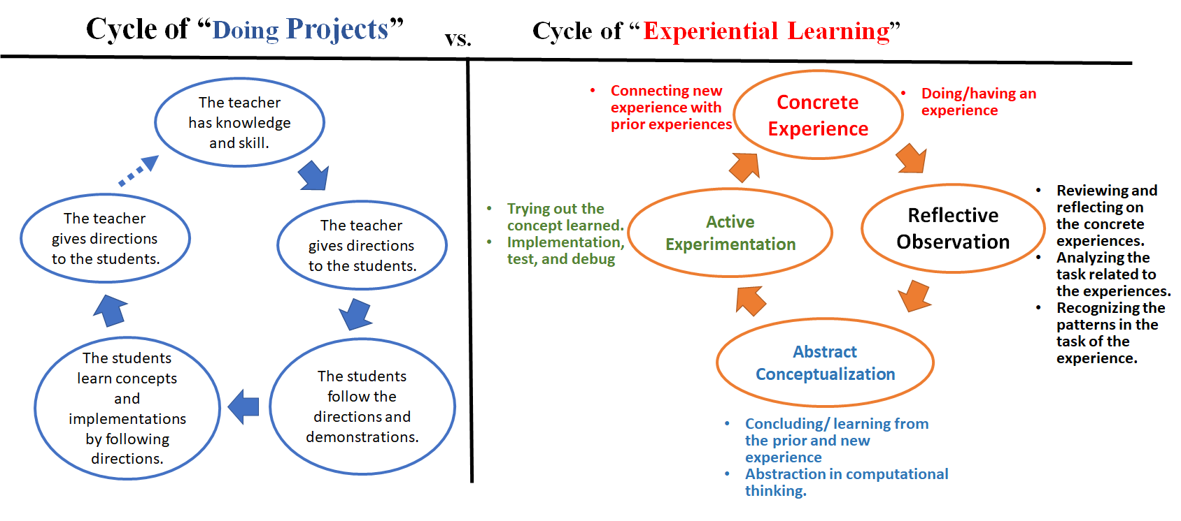

Participants
A total of 46 seventh-grade students participated in the conversational AI curriculum, of whom 25 were assigned to the experiential learning condition, which we refer to as the experimental group, and 21 were assigned to the general cycle of doing projects, which we refer to as the control group, shown as Table 1.
Table 1
The Number of the Participants with Different Gender in Different Groups
Learning approaches | Gender | N
Cycle of Experiential Learning | Female | 11
(Experimental group) | Male | 14
Cycle of Doing Projects | Female | 7
(Control group) | Male | 14

The purpose of this research study was to determine whether the students could understand conversational artificial intelligence (the ability for a computer to have conversations with humans) and develop programming projects through formal classes in secondary school via two different learning approaches. Participation in the study was completely voluntary and the students’ parents also had to fill out the consent form. The students were able to decline to answer any or all of the questions. If a student declined to answer any of the questions, he or she would no longer be participating in the study. The students could decline participation at any time. The data collected in this study are reported in such a way that the identity of individuals is protected.

Experimental Process and Measuring Tools
The conversational AI curriculum took a total of 6 weeks. The students in the two classes learned computational thinking and AI skills from the curriculum after they developed their own conversational AI projects during the 6 weeks. The learning objectives of the conversational AI curriculum is to learn how conversational agents decide what to say, to comfortably develop the conversational AI projects, and to better understand conversational agents. Accordingly, the students were encouraged to develop positive, socially useful and meaningful projects in the course.
The pre-test of prior knowledge included 15 multiple-choice questions, with a perfect score 100. The post-test for measuring the learning effectiveness also comprised 15 multiple-choice questions, with a perfect score of 100.

Figure 6
The Experimental Flow Chart
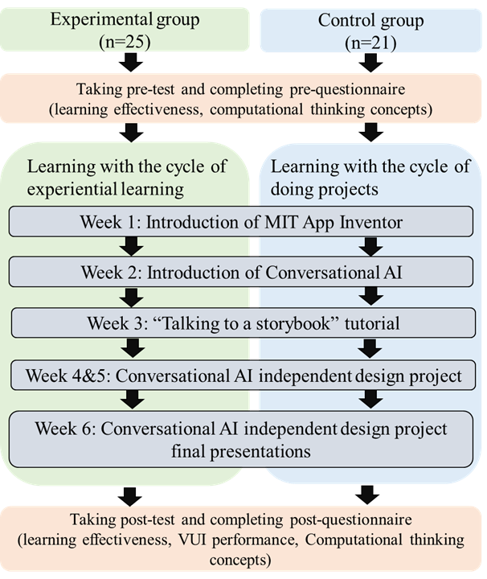

The VUI performance and computational thinking concepts were measured through Likert 5-point scales, ranging from "strongly disagree" to "strongly agree." The VUI performance scale has five questions (Van Brummelen, 2019), namely, “I have interacted with conversational agents”; “I understand how conversational agents decide what to say”; “I feel comfortable making apps that interact with conversational agents”; “I can think of ways that conversational agents can solve problems in my everyday life”; and “My understanding of conversational agents improved through the curriculum.” The Cronbach's α value of the reliability of the VUI performance scale was 0.883. The computational thinking concept scale has five questions, shown as Table 2 (Sáez-López et al., 2016). The reliability of the original combined scale is 0.789. The Cronbach's α value of the retest reliability of the computational thinking concept scale was 0.921.
Table 2
Computational Thinking Concept Scale of Graphical Programs (Sáez-López et al., 2016)
After learning block-based programming, I...
- Understand sequences with combined characters, backgrounds, and elements
- Can include loops in programming to allow a proper multimedia product
- Can add parallelism and events that allow the creation of interfaces
- Have an improved ability to share and play with the content created
- Acquired the ability to communicate and express through the content created

The students’ behaviors were video-recorded in the class. The recordings were used to infer and understand why the students learned well or not after the quantitative analysis.

Results
Learning Effectiveness of the Students with Different Learning Approaches and Different Genders
Two-Way ANCOVA was employed to compare the learning effectiveness of the conversational AI curriculum with different learning approaches (i.e., the cycle of doing projects and the cycle of experiential learning) and genders (males and females). The covariance was the pre-test used to measure the prior knowledge of the students before the conversational AI curriculum. The independent variables were the genders (i.e., males and females) and the learning approaches (i.e., the cycle of experiential learning and the cycle of conventionally doing projects). The dependent variable was the post-test used to measure the learning effectiveness of the students after the curriculum. The Levene’s test was not violated (F = 1.424, P=.249 > .050), suggesting that a common regression coefficient was appropriate for the two-way ANCOVA.
Table 3 shows the two-way ANCOVA results. It was found that there was interaction between the two independent factors, learning approaches and gender, for the students’ learning results (F = 12.493**, P=.001 < .010). The effect size (Partial η²) was 0.247, indicating a medium effect.

Table 3
Two-Way ANCOVA Tests of Between-Subjects Effects
Resources | SS | MS | F | P | Partial η²
Learning Approaches * Pre-test | 362.82 | 362.82 | 0.929 | .341
Gender * Pre-test | 898.18 | 898.18 | 2.300 | .138
Learning Approaches | 117.24 | 117.24 | 0.300 | .587
Gender | 83.65 | 83.65 | 0.214 | .646
Learning Approaches * Gender | 4879.23 | 4879.23 | 12.493** | .001 | 0.247
^{**p<.01}
A simple main-effect analysis based on the division of gender was explored in Table 4. When the group was divided based on gender, the Levene’s test was not violated (F = 0.086, P=.772 > .050) for male, and the Levene’s test was not violated (F = 2.137, P=.163 > .050) for female. However, pretest had interaction with learning approaches (F=4.803*; P=.038<.050) for male. Moreover, pretest had interaction with learning approaches (F=8.012*; P=.013<.050) for female. Therefore, the Johnson-Neyman process was further conducted.

Table 4
The Simple Main-Effect Analysis Based on the Division of Gender
Gender | Learning Approaches | N | Mean | SD | Adjusted Mean | SE
Female | Cycle of experiential learning | 11 | 71.52 | 19.34 | 71.48 | 6.76
 | Cycle of doing projects | 7 | 67.84 | 8.50 | 67.84 | 8.50
Male | Cycle of experiential learning | 14 | 42.86 | 21.04 | 42.15 | 6.47
 | Cycle of doing projects | 14 | 59.05 | 23.37 | 59.68 | 6.37
^{*p<.05}
In terms of males, it was found that when the pretest was smaller than 57.646, the male students using the cycle of doing projects outperformed the male students using the cycle of experiential learning, shown as Figure 7. Conversely, the high-prior competence of the males using the cycle of experiential learning performed better than the high-prior competence of the males using the cycle of doing projects.

Figure 7.
The Results of Johnson-Neyman Process for Males Using Different Learning Approaches
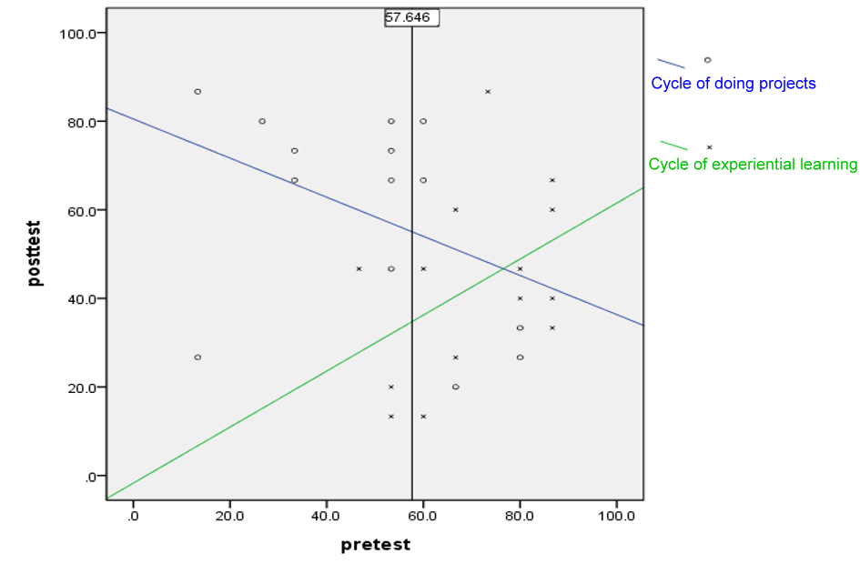

As for females, it was found that when the pretest was smaller than 44.026, the female students using the cycle of experiential learning outperformed the female students using the cycle of doing projects. Conversely, when the pretest was larger than 72.864, the female students using the cycle of doing projects could perform better than the female students using the cycle of experiential learning, shown as Figure 8.

Figure 8.
The Results of Johnson-Neyman Process for Females Using Different Learning Approaches
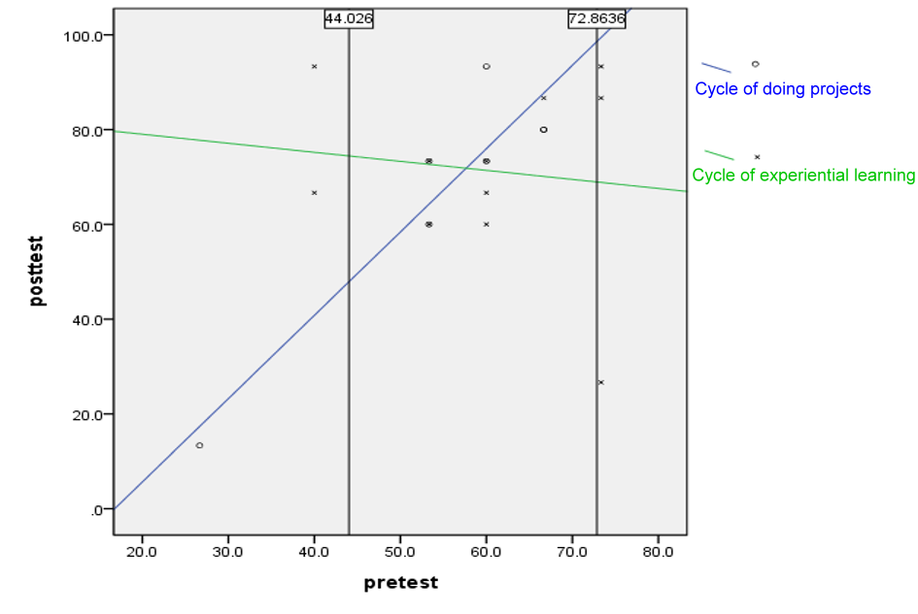

A simple main-effect analysis based on the division of learning approaches was further explored in Table 5. When the group was divided based on learning approaches, the Levene’s test was not violated (F = 0.116, P=.737 > .050) for the cycle of experiential learning approach, and the Levene’s test was not violated (F = 4.101, P=.057 > .050) for the cycle of doing project approach. The pretest did not have interaction with gender (F=1.596; P=.220>.050) for the cycle of experiential learning approach. However, the pretest had interaction with gender (F=12.146**; P=.003<.010) for the cycle of doing project approach. Therefore, the Johnson-Neyman process was further conducted.
Table 5
The Simple Main-Effect Analysis Based on the Division of learning approaches
Learning approaches | Gender | N | Mean | SD | Adjusted Mean | SE
Cycle of experiential  learning | Female | 11 | 71.52 | 19.34 | 71.48 | 6.76
 | Male | 14 | 42.86 | 21.04 | 42.15 | 6.47
Cycle of doing projects | Female | 7 | 67.62 | 25.94 | 67.84 | 8.50
 | Male | 14 | 59.05 | 23.37 | 59.68 | 6.37

As for the group using the cycle of doing project approach, it was found that when the pre-test was smaller than 35.849, the males outperformed the females. Conversely, when the pre-test was larger than 59.310, the females performed better than the males, shown as Figure 9.

Figure 9.
The Results of Johnson-Neyman Process for Males and Females Using the Cycle of Doing Project Approach
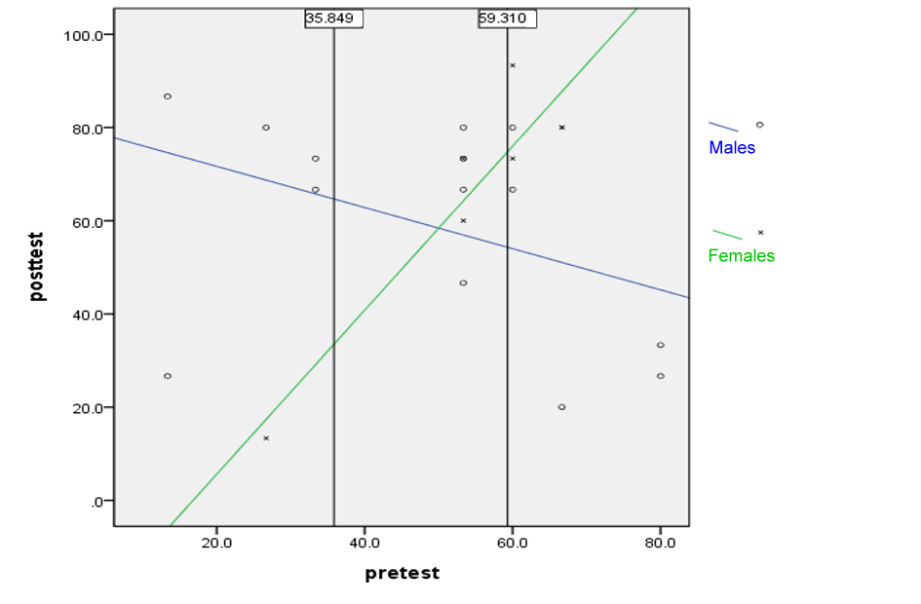

Consequently, the instructors have best to take the prior-knowledge of the students into consideration when they choose the learning approaches for the secondary school students to learn the conversational AI curriculum. Overall, the cycle of experiential learning is as effective as the cycle of doing projects for the conversational AI curriculum. However, there is a significant interaction between genders and learning approaches when learning the conversational AI curriculum. From the classroom observations, this study found that most of the males tended to be distracted in class when they firstly learned AI curriculum.

The VUI Performance of the Students with Different Learning Approaches and Different Genders
There were five items in the investigation of the performance of VUI. The Two-Way ANOVA was introduced to analyze the average scores of the five items determining whether students can understand conversational artificial intelligence (the ability for a computer to have conversations with humans) and develop programming projects through the formal class in the secondary school with two different learning approaches. The dependent variable was the survey results after the instructional experiment. The two independent variables were gender and learning approach. The Levene’s test of determining homogeneity of regression was not violated (F(3,42) = 1.303, P=.286 > .05).
Table 6 shows the two-way ANOVA results of the VUI performance. It was found that there was significant impact on the interaction between learning approaches and genders (F = 4.581*, P=.035 < 0.05, Partial η2 = 0.098). At the same time, it was found that there were significant effects for gender (F = 6.543*, P=.014 < 0.05, Partial η2 = 0.135) on students' perspectives of the conversational AI curriculum, while no significant effect was found for students’ perspectives in the different learning approach conditions (F = 0.330, P =.569 > .05).

Table 6
Tests of Between-Subject Effects Measure in the Two-way ANOVA for VUI Performance
Source factors | Type III SS | MS | F | P | Partial η²
Learning approaches | 0.262 | 0.262 | 0.330 | .569
Gender | 5.204 | 5.204 | 6.543* | .014 | 0.135
Learning approaches * Gender | 3.644 | 3.644 | 4.581* | .038 | 0.098
^{*p<.05}
Because there was interaction between students’ VUI performance in the different learning approach conditions and for the different genders, the simple main-effect analysis was further conducted. From Table 7, it was found that the VUI performance of the females learning the conversational AI curriculum with the cycle of experiential learning (Mean=4.00; SD=0.63) or the cycle of doing projects (Mean=4.43; SD=0.63) was similar (t=1.416; P=.176>.05). Furthermore, no significant difference (t=1.924, P=.065>.050) was found between the perspectives of males with the cycle of experiential learning (Mean=3.88; SD=1.03) and the cycle of the doing projects approach (Mean=3.14; SD=1.01). In the cycle of doing projects, females’ VUI performance (Mean=4.43; SD=0.63) outperformed males’ (Mean=3.14; SD=1.01), which resulted in a significant difference (t=2.923**; P=.009<.01) with an effect size of 1.53. In the experiential learning approach, no significant difference (t=0.322; P=.750>.050) was found between the VUI performance of females (Mean=4.00; SD=0.63) and males (Mean=3.88; SD=1.03). Overall, the VUI performance of the females outperformed that of the males.
Table 7
The Descriptive Statistics Results After the Simple Main-Effect Analysis in VUI Performance
Learning approaches | Gender | N | Mean | SD | Adjusted Mean | SE
Cycle of experiential learning | Female | 11 | 4.00 | 0.63 | 4.00 | 0.27
 | Male | 14 | 3.88 | 1.03 | 3.89 | 0.24
Cycle of doing projects | Female | 7 | 4.43 | 0.63 | 4.43 | 0.34
 | Male | 14 | 3.14 | 1.01 | 3.14 | 0.24

Figure 10 shows the interaction between the different learning approaches and genders on the students’ VUI performance. In the cycle of doing projects, the VUI performance of females was significantly better than that of males.
Figure 10
The Interaction Between Learning Approaches and Gender on VUI Performance of the Students

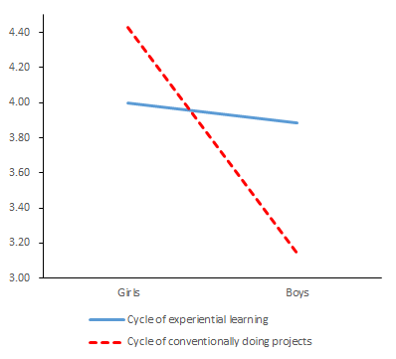

The Computational Thinking Scale of the Students with Different Learning Approaches and Genders
The Two-Way ANCOVA was employed to compare the computational thinking concepts of students using the different instructional approaches and the different genders. The covariance was the measurement of the computational thinking pre-measurement. The independent variables were the genders (i.e., male and female) and the learning approaches (i.e., experiential learning and project-based learning). The dependent variable was the post-measurement of the computational thinking scale. Levene’s test was not violated (F(3,42) = 0.636, P=.596 > .050), suggesting that a common regression coefficient was appropriate for the two-way ANCOVA.
Table 8 shows the two-way ANCOVA results on the computational thinking scale. It was found that the covariance (i.e., the pre-measurement of computational thinking) would not cause significant effects on the interaction between the two factors, learning approaches and gender, for the students’ computational thinking concepts. Therefore, it was meaningful to directly examine the interaction between the learning approaches and genders on the computational thinking concepts of the students. When the pre-measurement was not taken into consideration in the interaction, there was significant interaction between the two independent variables (i.e., gender and learning approaches) (F(3,42) = 7.047*, p=.011 < 0.050). Furthermore, the effect size (partial η²) of the interaction between learning approaches and gender was 0.147, indicating a small to medium effect, larger than 0.10 presenting a small effect (Cohen, 1988).

Table 8
The Two-Way ANCOVA Tests of Between-Subjects Effects on Computational Thinking Concepts
Resources | SS | MS | F | P | Partial η²
Learning Approaches * Pre-test | 0.12 | 0.12 | .200 | .658
Gender *Pre-test | 2.02 | 2.02 | 3.438 | .071
Learning Approaches * Gender * Pre-test | 0.53 | 0.53 | 0.896 | .350
Learning Approaches | 0.00 | 0.00 | 0.000 | .992
Gender | 0.33 | 0.33 | 0.537 | .468
Learning Approaches * Gender | 4.30 | 4.30 | 7.047* | .011 | 0.147
^{*p<.05}

Because the interaction between learning approaches and gender was significant, the simple main-effect analysis was further implemented. Table 9 showed that the computational thinking of males with the experiential learning approach (Mean=3.86; SD=0.91) outperformed (t=2.140*; P=.042<0.50) the computational thinking of males with the cycle of doing projects (Mean=3.19; SD=0.74), which had an effect size of 0.81. In the conventional instruction with the cycle of doing projects, females (Mean=4.20; SD=0.77) presented significantly (t=3.066**; P=.006<.010) better computational thinking concepts than males (Mean=3.19; SD=0.74) with an effect size of 1.34. There was no significant difference (t=1.791, P=.095>.050) between the computational thinking of females with the cycle of experiential learning approach (Mean=3.51; SD=0.85) and the cycle of doing projects (Mean=4.20; SD=0.77).

Table 9
The Descriptive Data after the Simple Main-Effect Analysis for Computational Thinking Concepts
Learning approaches | Gender | N | Mean | SD | Adjusted Mean | SE
Cycle of experiential learning | Female | 11 | 3.51 | 0.85 | 3.44 | 0.24
 | Male | 14 | 3.86 | 0.91 | 3.90 | 0.21
Cycle of doing projects | Female | 7 | 4.20 | 0.77 | 4.08 | 0.30
 | Male | 14 | 3.19 | 0.74 | 3.26 | 0.21

Discussion and Conclusion
According to the results of this empirical study, when the teachers want the instruct the secondary school students to learn the conversational AI curriculum, it is recommended that the low-achievement males and high-achievement females adopt the cycle of doing projects. It is also suggested that the high-achievement males and low-achievement females utilize the cycle of experiential learning, so as to meet their individual differences.
From the empirical study of applying the conventional cycle of doing projects to the conversational AI curriculum, it was found that females performed better than males in terms of computational thinking concepts. Based on information processing theory in cognitivism, males and females do not have the same level of focus when receiving and processing information. Since males require strong context linkage when processing information according to this theory, we suggest that instructors provide additional scaffolding, especially focusing on context for males in the conversational AI curriculum, so as to prevent the males from being distracted, like the situation observed and found in this study.
According to information processing theory, females focus on sharing information and developing correlations among information which they are aware of. In comparison with males, females are used to accepting the information in detail and understanding the detailed process. Therefore, it is meaningful and essential to explore the effects of various learning approaches on different-gender students learning AI in K-12 in the future. The limitation of this study includes the sample size of the instructional experiments, and the number of the countries having experiences in learning the new function of the conversational AI in MIT App Inventor. Due to more and more population of IoT in the technology society, future research is encouraged to apply the conversational AI tool used in the current study into IoT education of K-12.

Statements on Open Data, Ethics and Conflict of Interest
The dataset is available by contacting the corresponding author.
The ethics rules and regulations were followed during the experiment. All the participants voluntarily participated in the experiment and were told that they could quit the study at any time.
This study has no conflict of interest.

Acknowledgements
This study is supported in part by the Ministry of Science and Technology under contract numbers MOST 108-2511-H-003 -056 -MY3 and by the Hong Kong Jockey Club Charities Trust.

References
Adya, M., & Kaiser, K. M. (2005). Early determinants of women in the IT workforce: A model of girls' career choices. Information Technology and People, 18(3), 230-259. https://doi.org/10.1108/09593840510615860
Brennan, K., & Resnick, M. (2012). New frameworks for studying and assessing the development of computational thinking. In Proceedings of the 2012 annual meeting of the American Educational Research Association (pp. 1-25), April 13- 17, 2012. Vancouver, Canada.
Cetin, I. (2016). Preservice teachers’ introduction to computing: exploring utilization of scratch. Journal of Educational Computing Research, 54(7), 997-1021. https://doi.org/10.1177/0735633116642774
Cheng, G., (2019). Exploring factors influencing the acceptance of visual programming environment among boys and girls in primary schools. Computers in Human Behavior, 92, 361-372. https://doi.org/10.1016/j.chb.2018.11.043
Cheryan, S., Ziegler, S. A., Montoya, A. K., & Jiang, L. (2017). Why are some STEM fields more gender balanced than others? Psychological Bulletin, 143(1), 1-35.
Chiu, C. F. (2020). Facilitating K-12 Teachers in Creating Apps by Visual Programming and Project-based Learning. International Journal of Emerging Technologies in Learning, 15(01), 103-118.
Efstratia, D. (2014). Experiential Education through Project Based Learning. Procedia - Social and Behavioral Sciences, 152, 1256-1260. https://doi.org/10.1016/j.sbspro.2014.09.362
Grover, S., & Pea, R. (2013). Computational Thinking in K–12: A Review of the State of the Field. Educational Researcher, 42(1), 38–43. https://doi.org/10.3102/0013189X12463051
Hsu, T.-C., Abelson, H., Lao, N., Tseng, Y.-H. & Lin, Y.-T. (2021). Behavioral-pattern exploration and development of an instructional tool for young children to learn AI. Computers and Education: Artificial Intelligence, 2, 100012. https://doi.org/10.1016/j.caeai.2021.100012
Hsu, T.-C., Chang, S.-C., & Hung, Y.-T. (2018). How to learn and how to teach computational thinking: Suggestions based on a review of the literature. Computers & Education, 126, 296-310. https://doi.org/10.1016/j.compedu.2018.07.004
Kalelioğlu, F. (2015). A new way of teaching programming skills to K-12 students: Code. org. Computers in Human Behavior, 52, 200-210. https://doi.org/10.1016/j.chb.2015.05.047
Kelleher, C., & Pausch, R. (2005). Lowering the barriers to programming: A taxonomy of programming environments and languages for novice programmers. ACM Computing Surveys, 37(2), 83-137. https://doi.org/10.1145/1089733.1089734
Korkmaz, Ö ., & Altun, H. (2013). Engineering and ceit student's attitude towards learning computer programming. International Journal of Social Science Studies, 6(2), 1169-1185.
Lindh, J., & Holgersson, T. (2007). Does LEGO training stimulate pupils' ability to solve logical problems? Computers & Education, 49(4), 1097-1111. https://doi.org/10.1016/j.compedu.2005.12.008
Long, D., & Magerko, B. (2020, April). What is AI Literacy? Competencies and Design Considerations. In Proceedings of the 2020 CHI Conference on Human Factors in Computing Systems (pp. 1-16).
Lye, S. Y., & Koh, J. H. L. (2014). Review on teaching and learning of computational thinking through programming: What is next for K-12? Computers in Human Behavior, 41, 51–61. https://doi.org/10.1016/j.chb.2014.09.012
Martin, C. L., Ruble, D. N., & Szkrybalo, J. (2002). Cognitive theories of early gender development. Psychological Bulletin, 128(6), 903-933.
Meyers-Levy, J. (1986). Gender differences in information processing: A selectivity interpretation. Northwestern University.
Meyers-Levy, J. (1989). The influence of a brand name's association set size and word frequency on brand memory. Journal of Consumer Research, 16(2), 197-207. https://doi.org/10.1086/209208
Ö zyurt, Ö ., & Ö zyurt, H. (2015). A study for determining computer programming students' attitudes towards programming and their programming self-efficacy. Journal of Theory and Practice in Education, 11(1), 51-67.
Piwek, P. & S. Savage (2020). Challenges with Learning to Program and Problem Solve: An Analysis of Student Online Discussions. In The 51st ACM Technical Symposium on Computer Science Education (SIGCSE ’20). New York: ACM.
Pucher, R. & Lehner M. (2011). Project Based Learning in Computer Science – A Review of More than 500 Projects. Procedia - Social and Behavioral Sciences, 29, 1561-1566. https://doi.org/10.1016/j.sbspro.2011.11.398
Putrevu, S. (2001). Exploring the origins and information processing differences between men and women: Implications for advertisers. Academy of marketing science review, 10(1), 1-14.
Sendall, P., Stuetzle, C. S., Kissel, Z. A., Hameed, T. (2019). Experiential Learning in the Technology Disciplines. In 2019 Proceedings of the EDSIG Conference. Ohio: ISCAP.
Thomas, J. W. (2000). A review of research on project-based learning, 1-45.https://tecfa.unige.ch/proj/eteach-net/Thomas_researchreview_PBL.pdf
Touretzky, D., Gardner-McCune, C., Martin, F., & Seehorn, D. (2019, July). Envisioning AI for K-12: What Should Every Child Know about AI?. In Proceedings of the AAAI Conference on Artificial Intelligence (Vol. 33, pp. 9795-9799).
Van Brummelen, J. (2019). Tools to Create and Democratize Conversational Artificial Intelligence (master’s thesis, MIT, Cambridge). https://hdl.handle.net/1721.1/122704
Weston, T. J., Dubow, W. M., Kaminsky, A. (2019). Predicting Women's Persistence in Computer Science- and Technology-Related Majors from High School to College. ACM Transactions on Computing Education, 20(1). https://doi.org/10.1145/3343195
Wyss, V. L., Heulskamp, D., Siebert, C. J. (2012). Increasing middle school student interest in STEM careers with videos of scientists. International Journal of Environmental & Science Education, 7(4), 501-522.
Yukselturk, E., & Altiok, S. (2017). An investigation of the effects of programming with Scratch on the preservice IT teachers' self-efficacy perceptions and attitudes towards computer programming. British Journal of Educational Technology, 48(3), 789–801. https://doi.org/10.1111/bjet.12453

